Terraform Final Task

This is how we will build the arch
VPC
├── Public Subnet
├── Internet Gateway
├── Route Table
├── Security Group
├── Network Interface
├── Elastic IP
└── EC2 (Apache)

1) Create VPC
Lets create a folder called Terraform- Final →main.tf
provider "aws" {
region = "us-east-1"

}
##########CREATING A VPC#############

resource "aws_vpc" "main" {
cidr_block = "10.0.0.0/16"

tags = {
Name = "Final Task VPC"
}
}

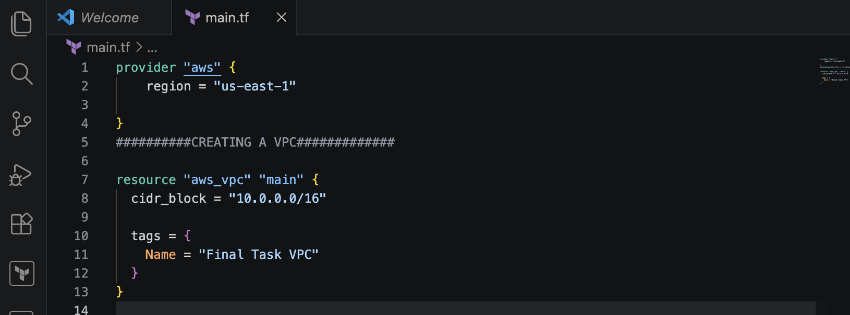
terraform init
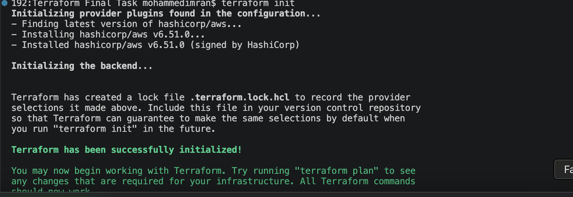terraform plan ⇒terraform apply
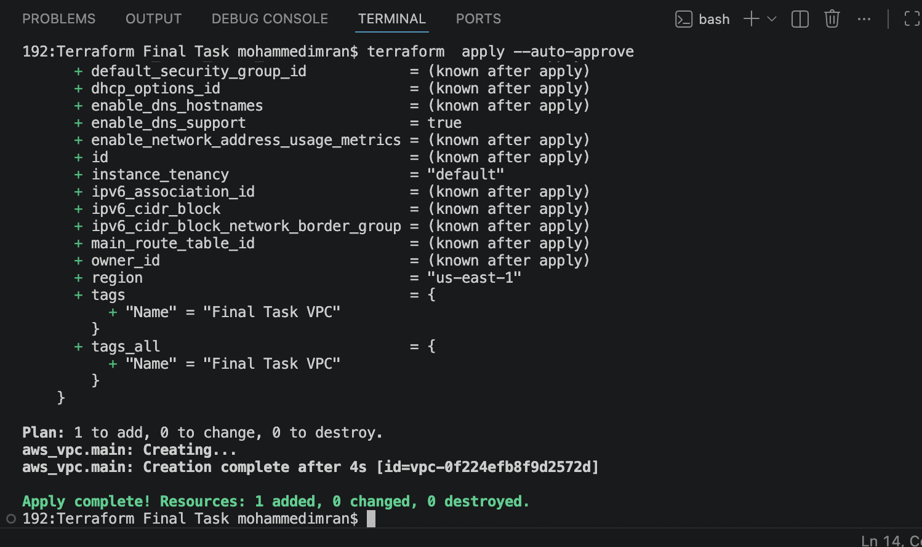

Lets confirm in AWS VPC
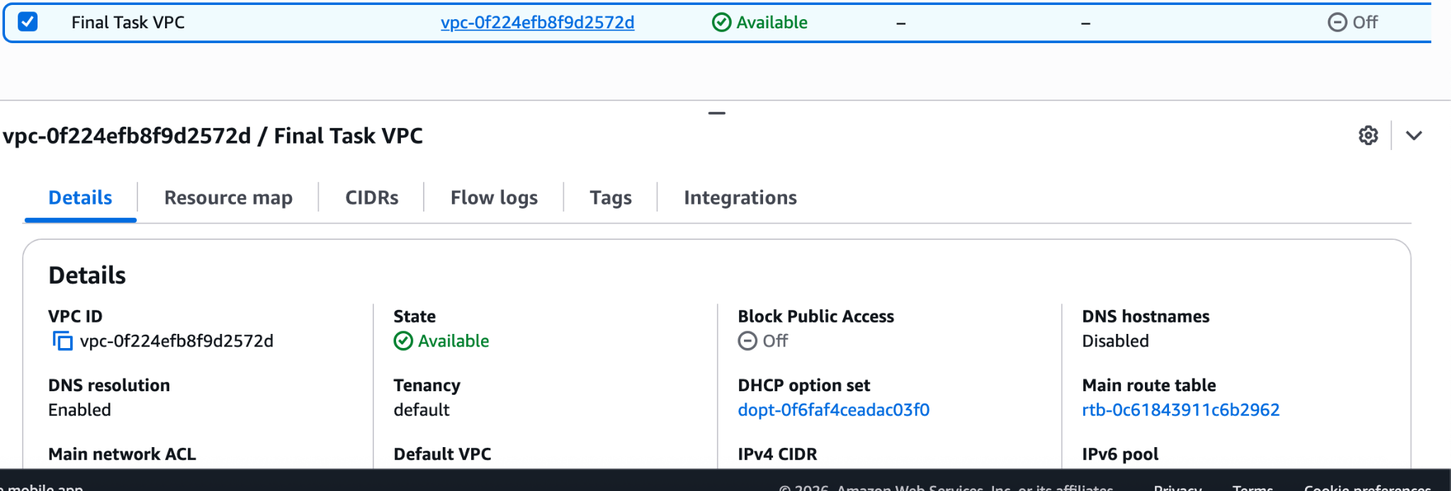

2) Create Internet gateway

###############CREATING A INTERNET GATEWAY####################

resource "aws_internet_gateway" "igw" {
vpc_id = aws_vpc.main.id

tags = {
Name = "TFT-igw"
}
}
#################################################################

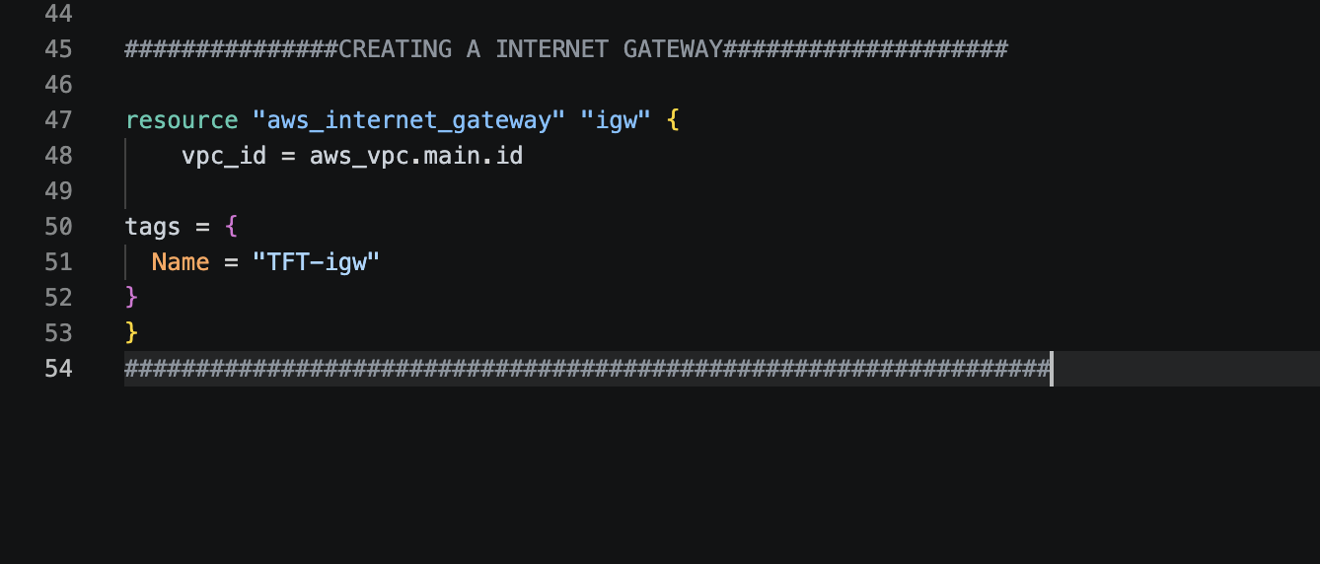

terraform fmt ⇒ terraform plan ⇒ terraform apply
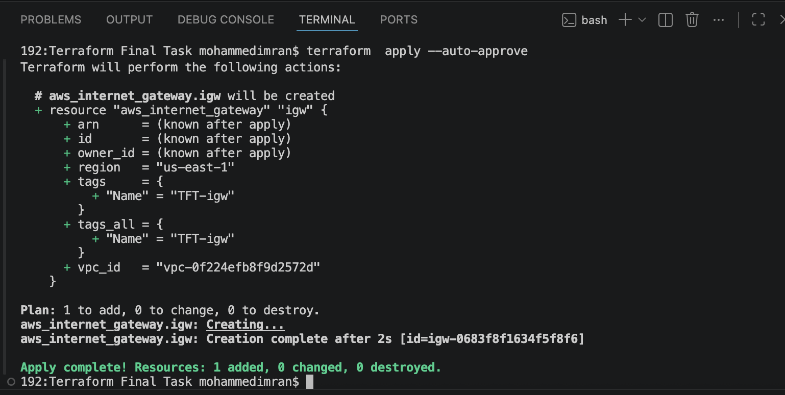
Confirming in AWS
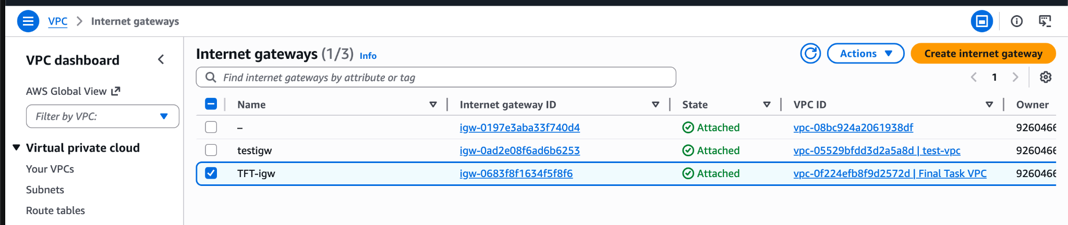

3) Create Custom Route Table

##############CREATING A ROUTE TABLE############################

resource "aws_route_table" "custom" {
vpc_id = aws_vpc.main.id
route {
cidr_block = "0.0.0.0/0"
gateway_id = aws_internet_gateway.igw.id
}

tags = {
Name = "Custom RT"
}
}

#############################################################

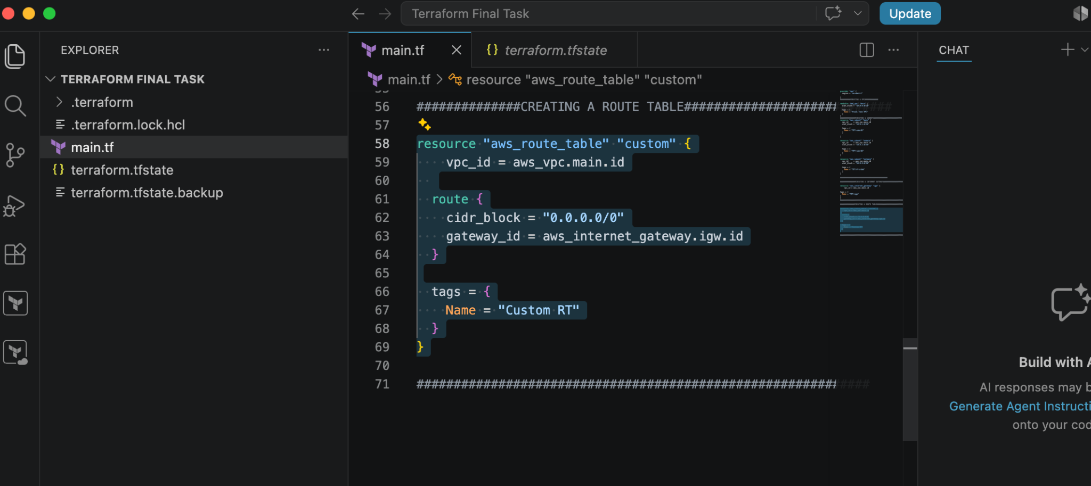
terraform plan ⇒terraform apply
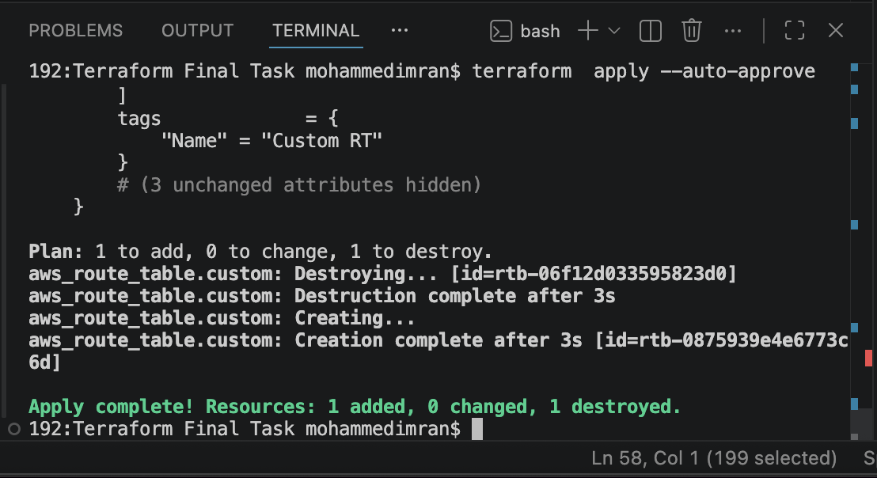
Confirming in AWS
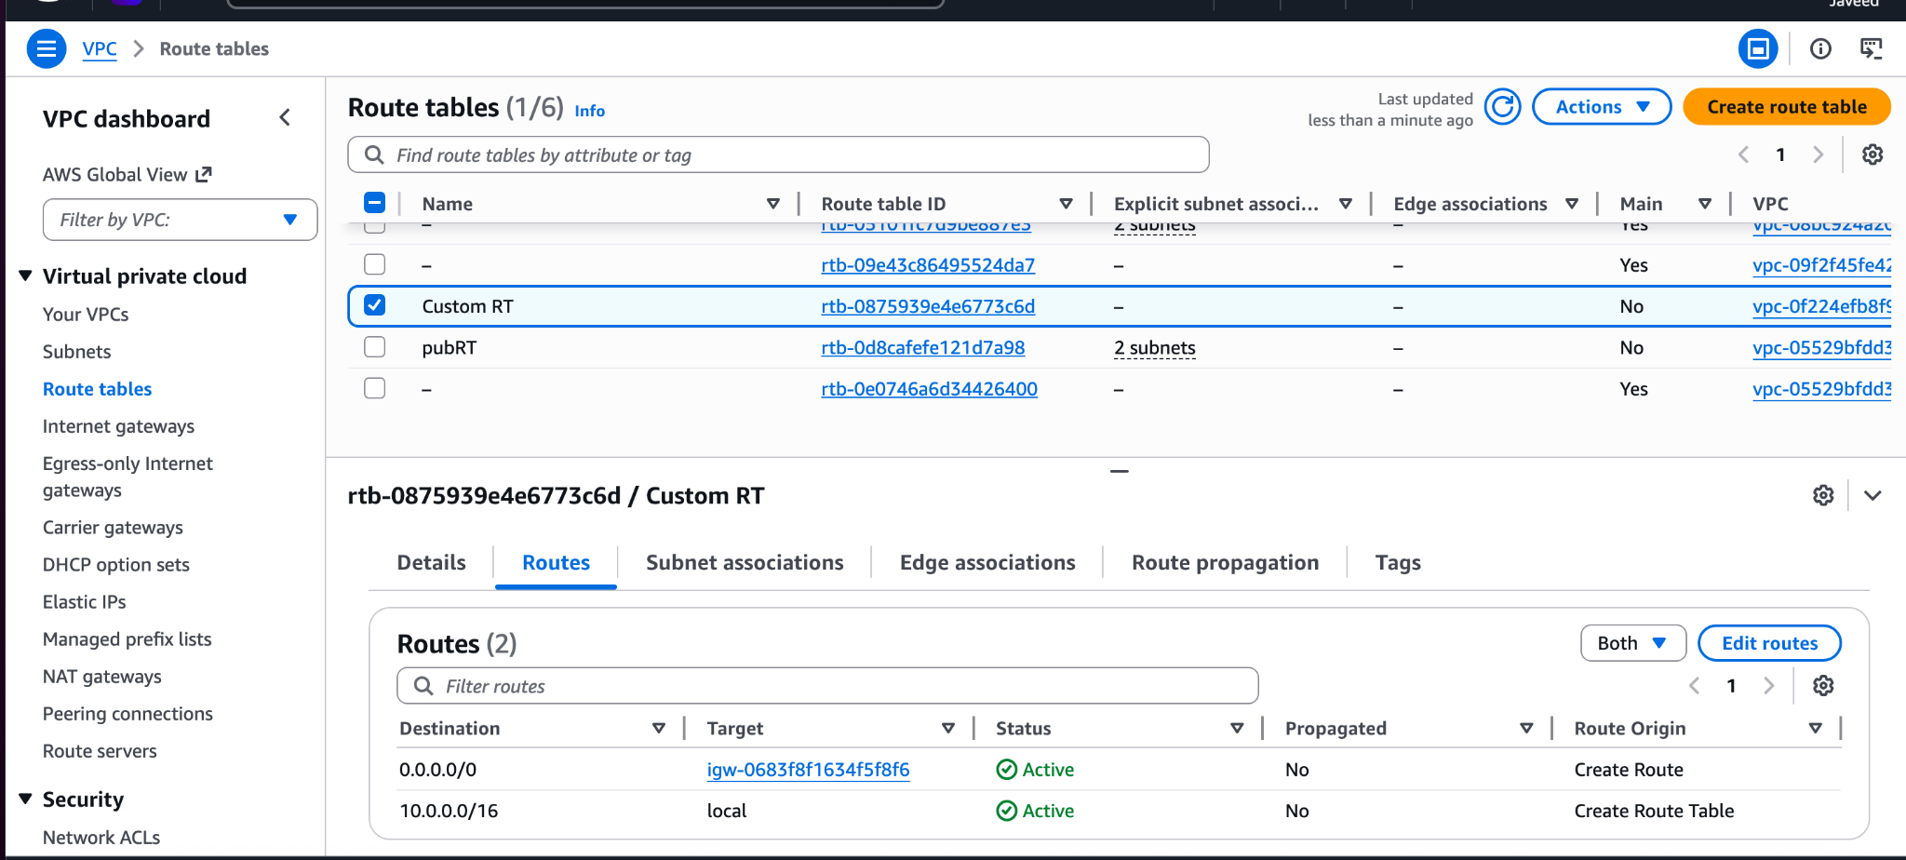

4) Create Subnet
###############CREATING A SUBNETS###########################
resource "aws_subnet" "main" {
vpc_id = aws_vpc.main.id
cidr_block = "10.0.1.0/24"
map_public_ip_on_launch = true

tags = {
Name = "TFT-sub-01"
}

}

resource "aws_subnet" "unmain" {
vpc_id = aws_vpc.main.id
cidr_block = "10.0.2.0/24"

tags = {
Name = "TFT-sub-02"
}
}

resource "aws_subnet" "notmain" {
vpc_id = aws_vpc.main.id
cidr_block = "10.0.3.0/24"

tags = {
Name = "TFT-Pri-Sub"
}
}

##############################################

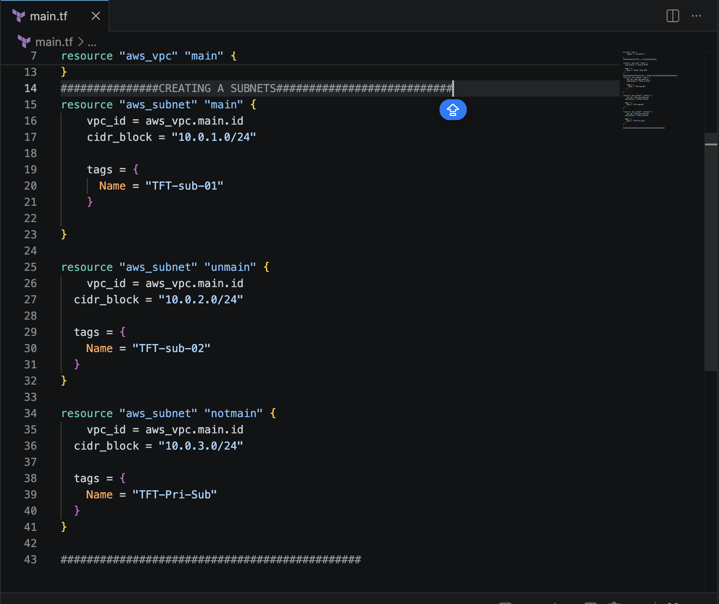
terraform plan
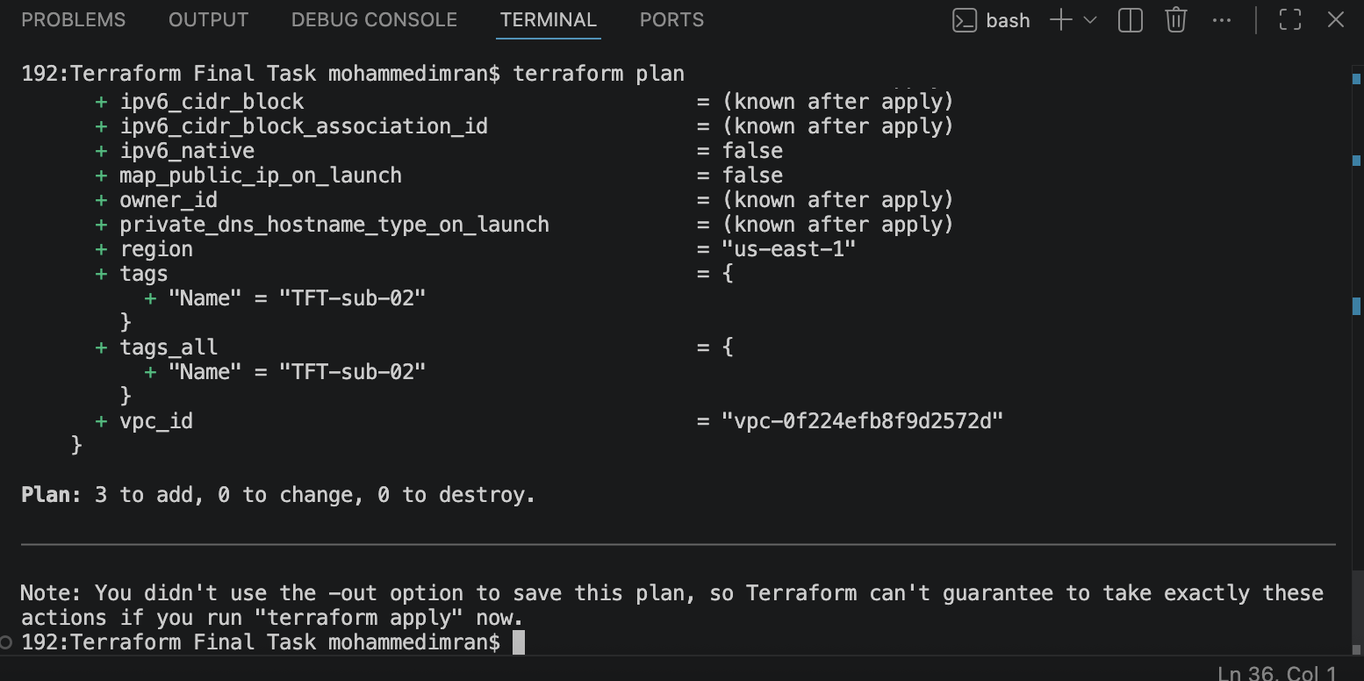
terraform apply
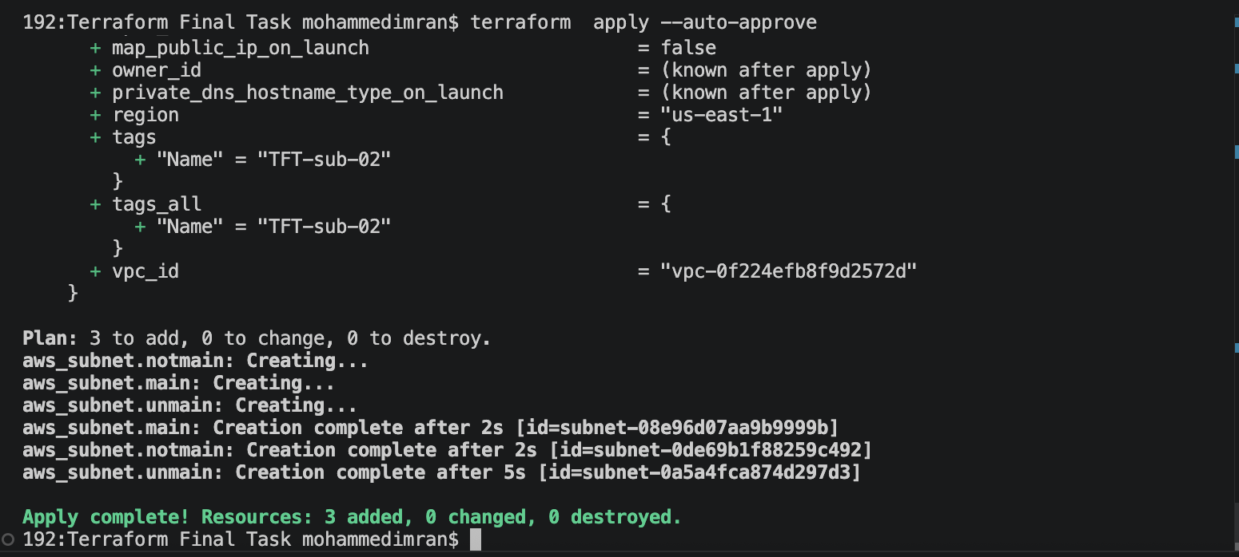
Confirming in AWS
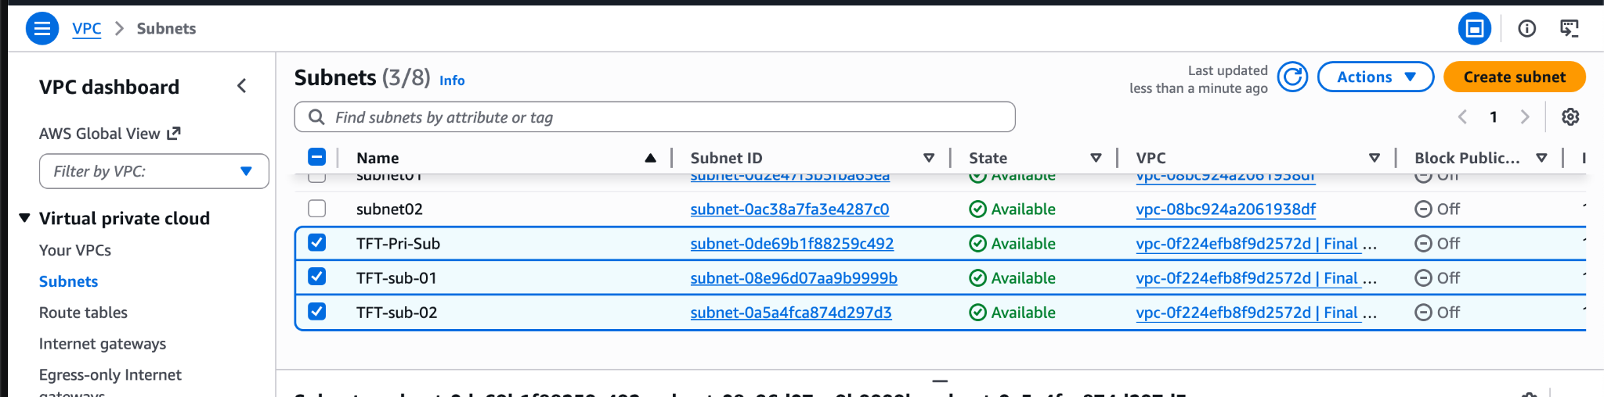

5) Associate subnet with Route Table

##############SUBNET ASSOCIATION WITH ROUTE TABLE#############

resource "aws_route_table_association" "Custom-RT" {
subnet_id = aws_subnet.main.id
route_table_id = aws_route_table.custom.id
}

###########################################################

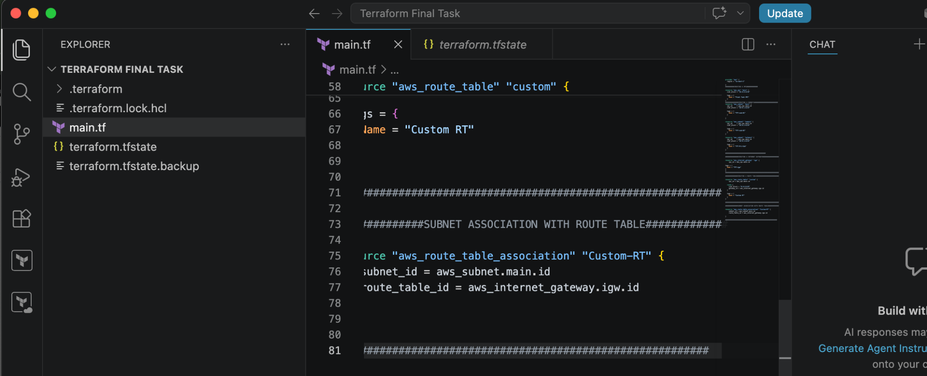
terraform plan ⇒ terraform apply
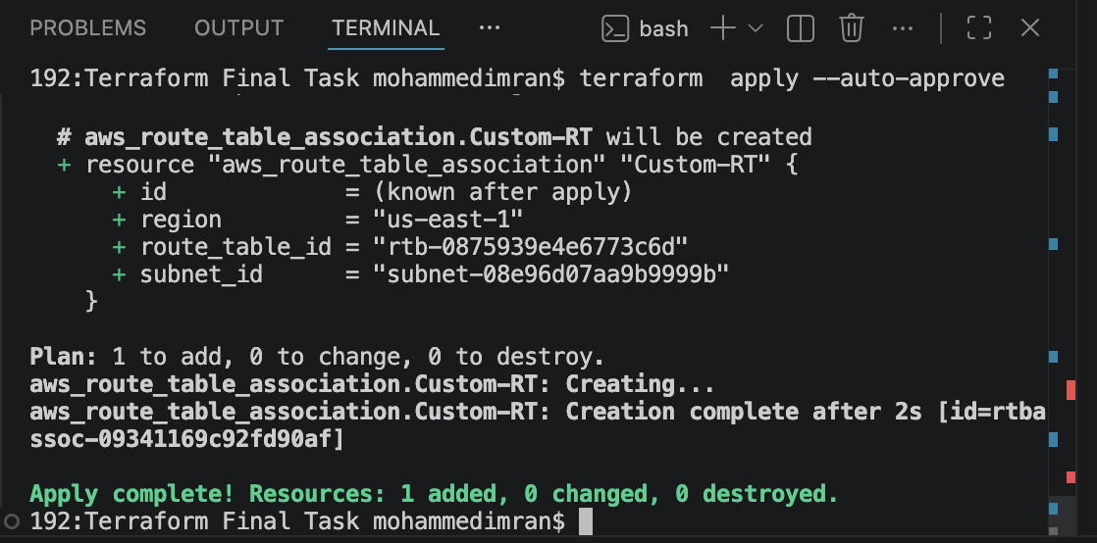
Confirming in AWS
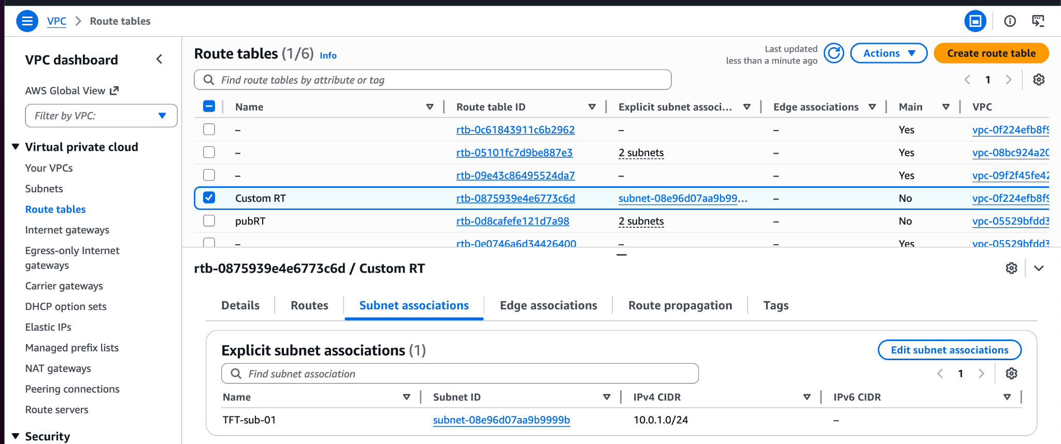

6) Create Security Group to allow port 22.80,443

#############SECURITY GROUP#######################

resource "aws_security_group" "sg" {
description = "Terraform Final task"
vpc_id = aws_vpc.main.id

ingress {
description = "Allow SSH"
from_port = 22
to_port = 22
protocol = "tcp"
cidr_blocks = ["0.0.0.0/0"]
}
ingress {
description = "Allow http"
from_port = 80
to_port = 80
protocol = "tcp"
cidr_blocks = ["0.0.0.0/0"]

}
ingress {
description = "Allow https "
from_port = 443
to_port = 443
protocol = "tcp"
cidr_blocks = ["0.0.0.0/0"]

}
egress {
description = "Allow All Traffic"
from_port = 0
to_port = 0
protocol = "-1"
cidr_blocks = ["0.0.0.0/0"]
}

tags = {
Name = "TFT-SG"
}
}
#########################################################

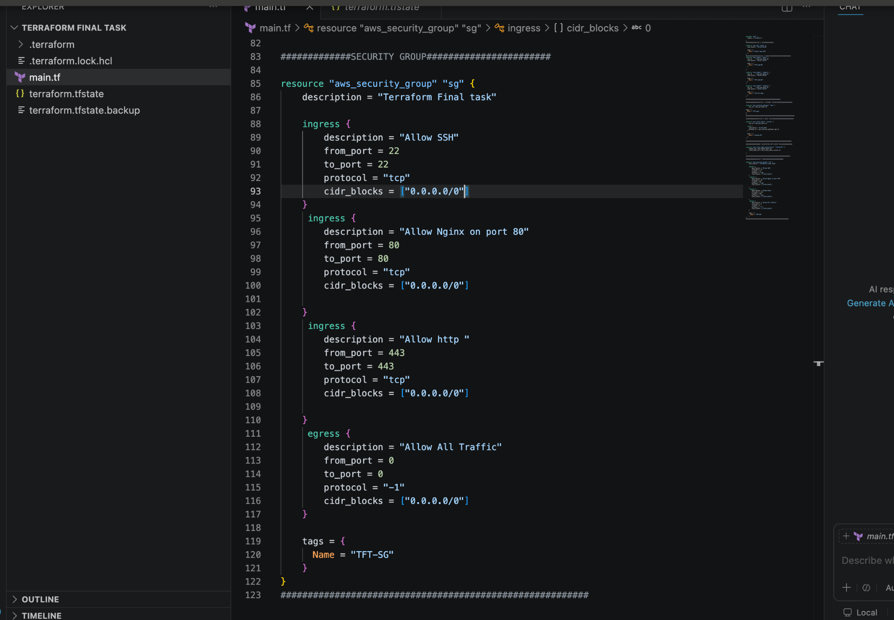
terraform plan⇒ terraform apply
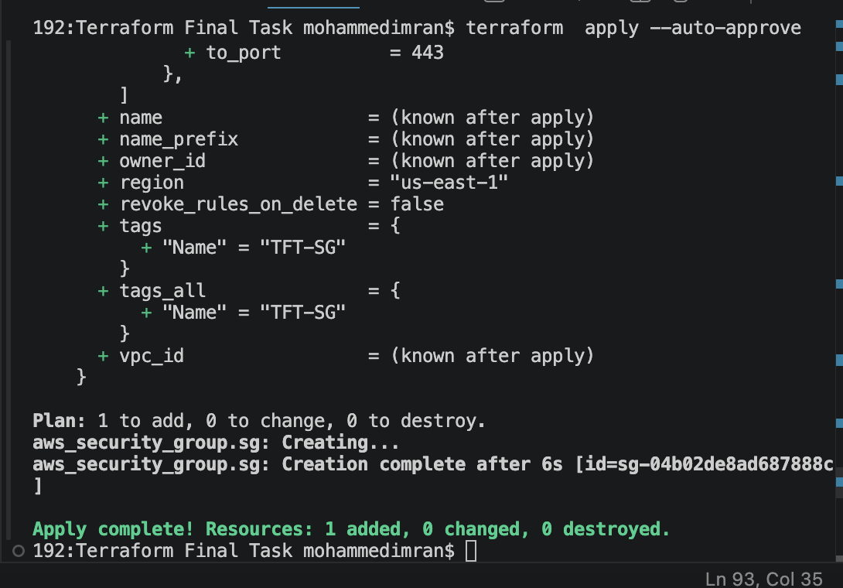
CONFIRMING IN AWS
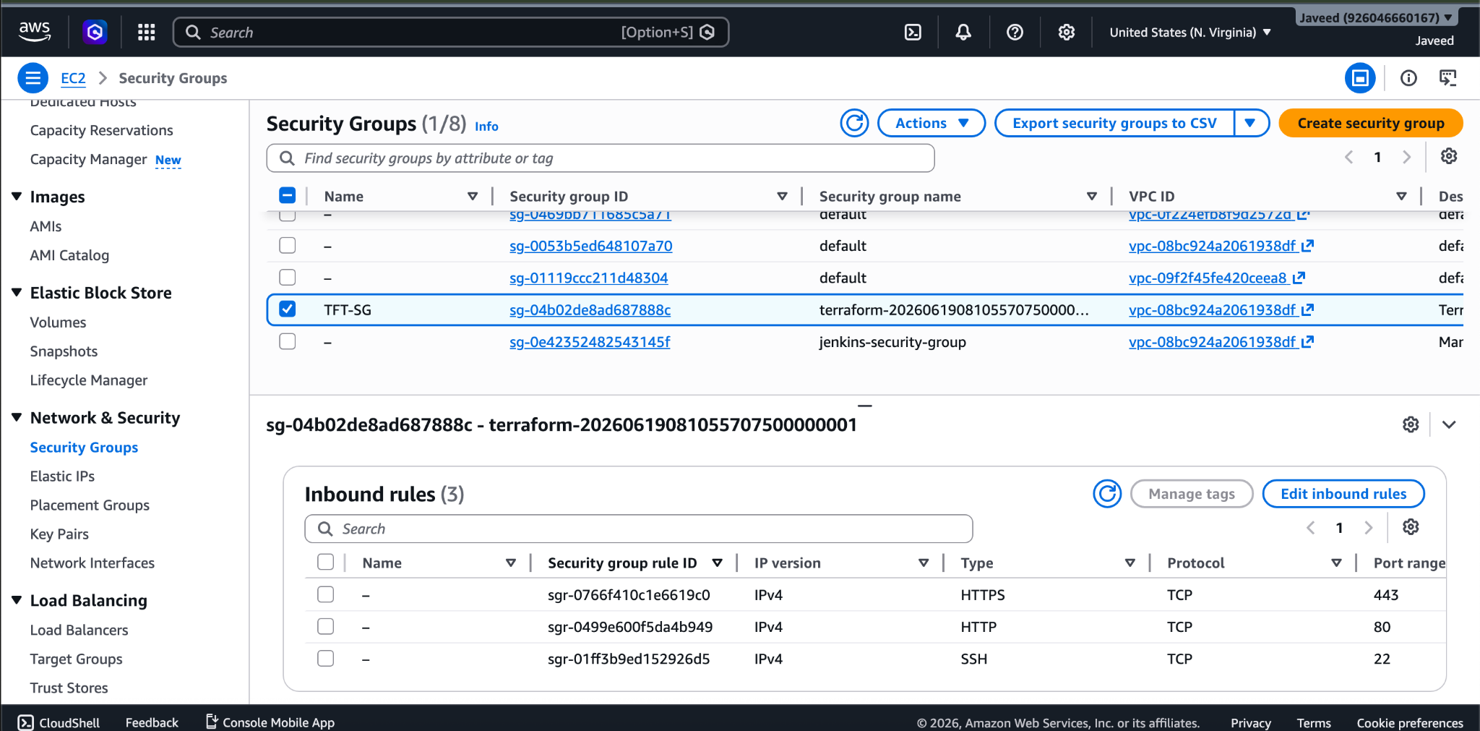

7) Create a network interface with an ip in the subnet that was created in step 4

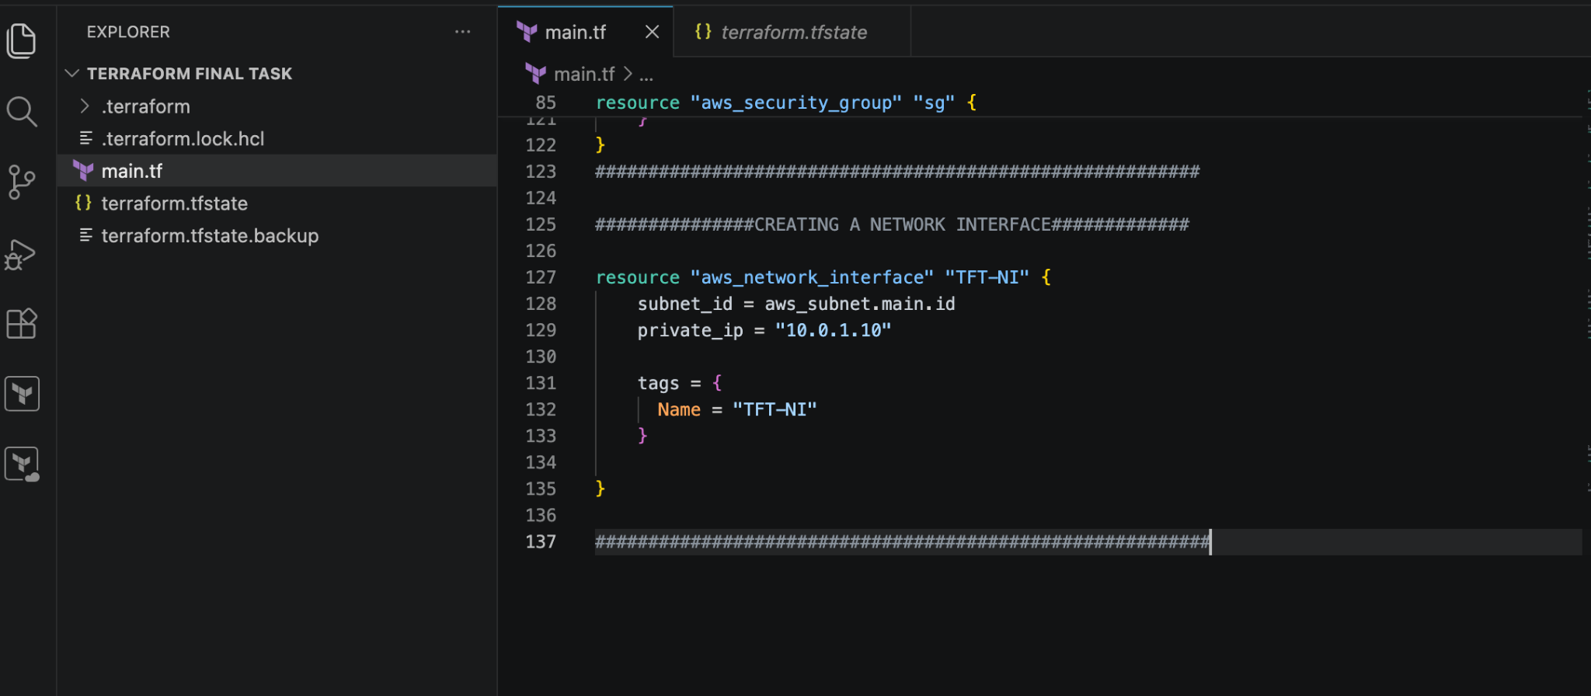
terraform apply
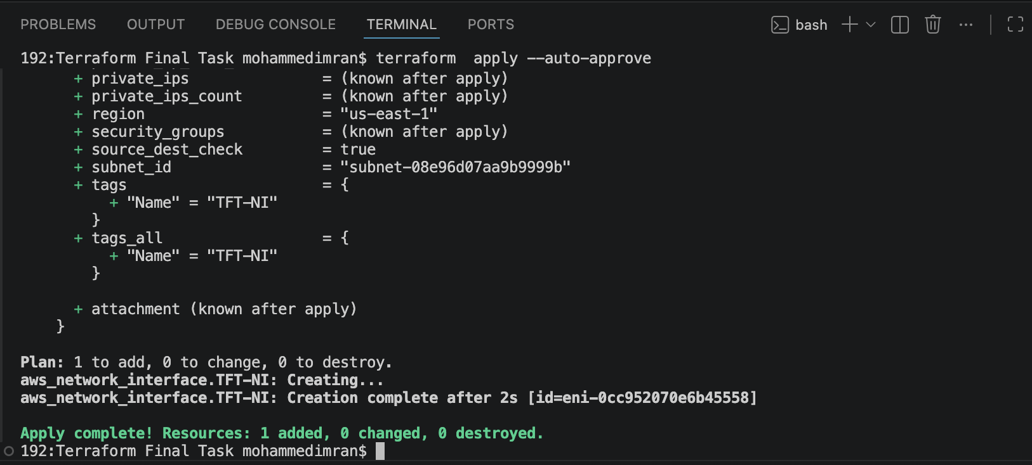
Confirming in AWS
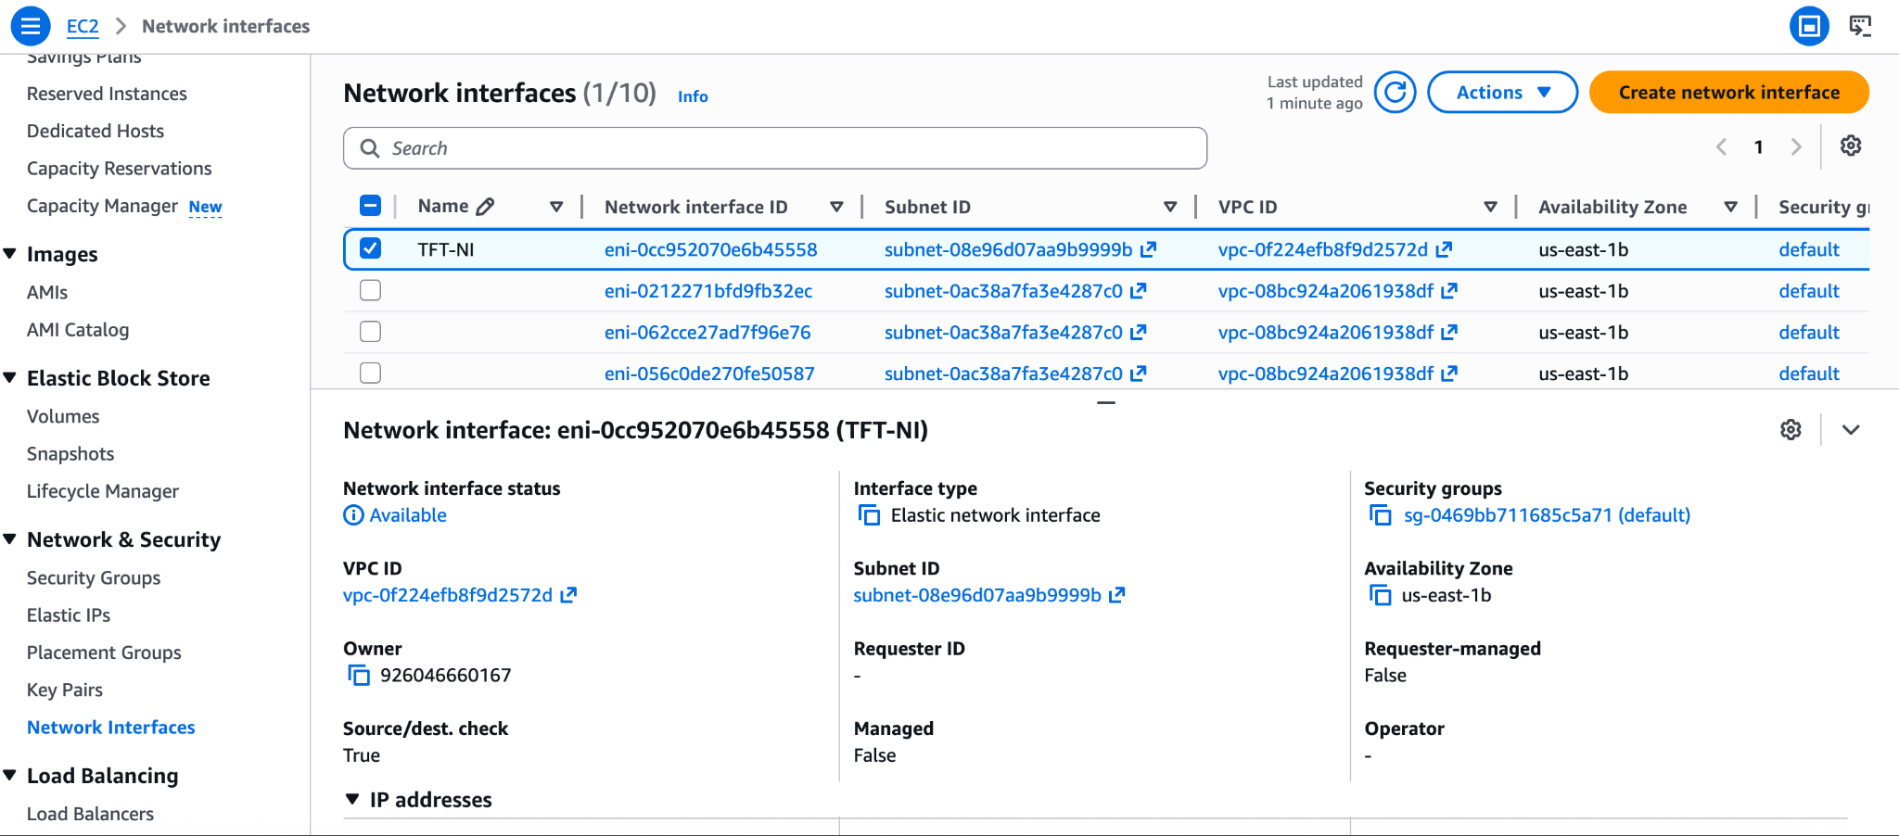

8) Assign an elastic IP to the network interface created in step 7

###############CREATING A NETWORK INTERFACE#############

resource "aws_network_interface" "TFT-NI" {
subnet_id = aws_subnet.main.id
private_ip = "10.0.1.10"
security_groups = [ aws_security_group.sg.id ]

tags = {
Name = "TFT-NI"
}
}

##########################################################

############ELASTIC IP####################################

resource "aws_eip" "assignEIP" {
domain = "vpc"
network_interface = aws_network_interface.TFT-NI.id

depends_on = [
aws_instance.TFT
]

tags = {
Name = "TFT-EIP"
}
}

#####################################################################

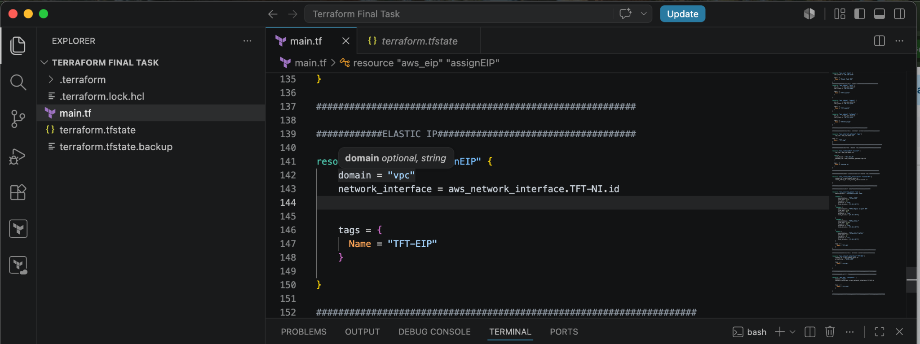
terraform apply
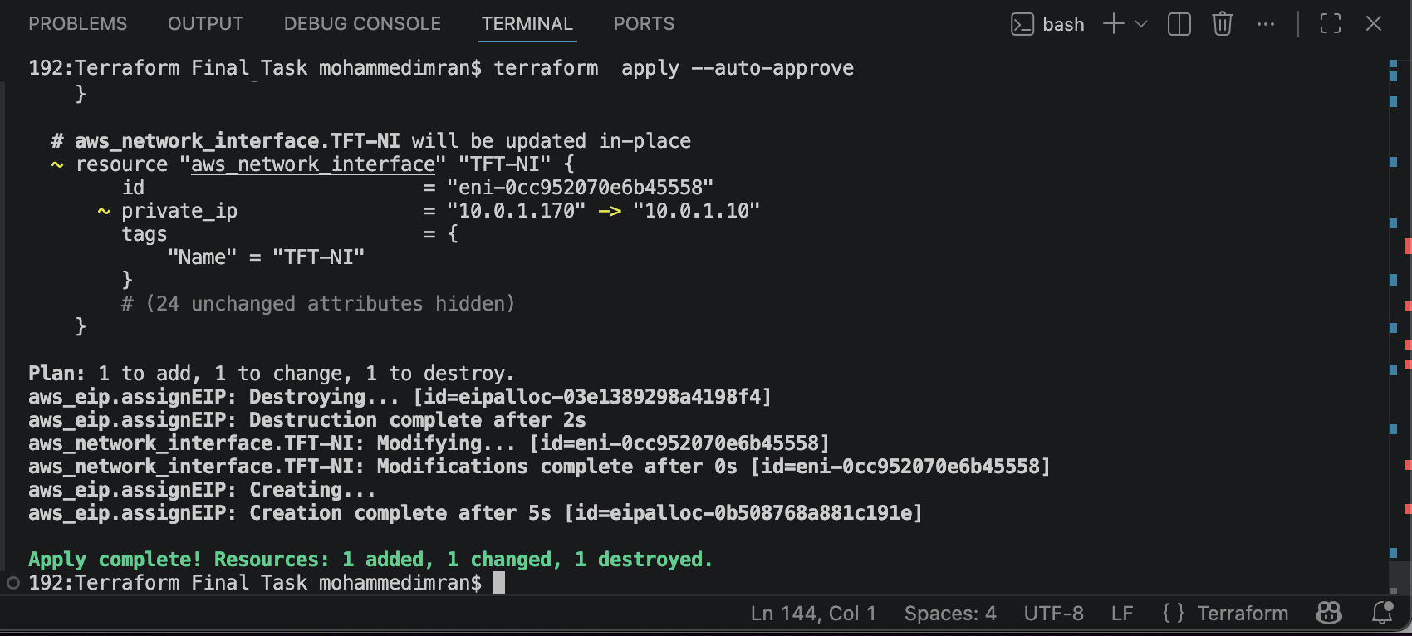
Confirming in AWS
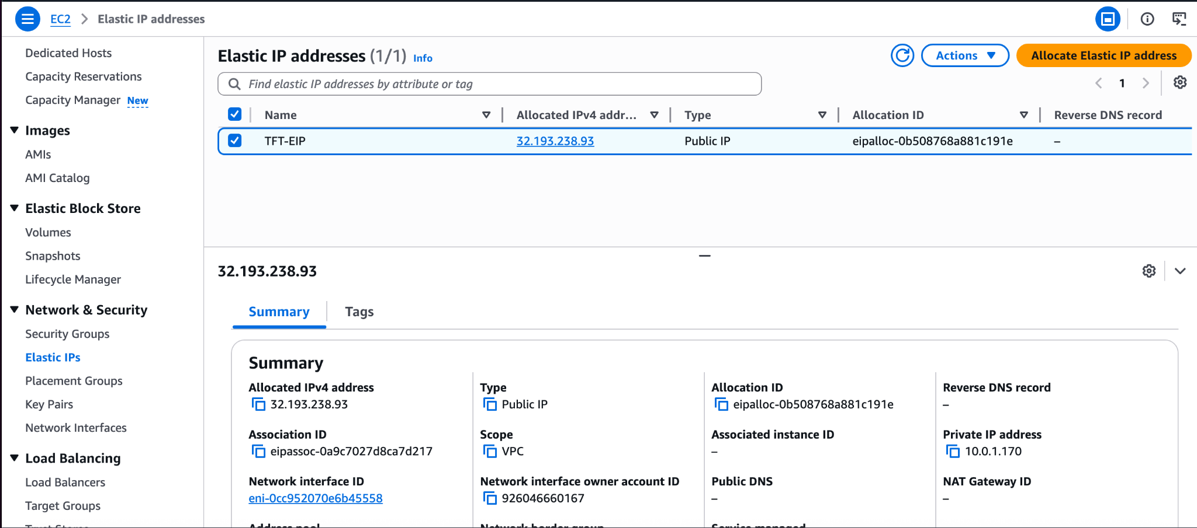

9) Create Ubuntu server and install/enable apache2

##################EC2 INSTANCE#######################################

resource "aws_instance" "TFT" {
ami = "ami-0b6d9d3d33ba97d99"
instance_type = "t3.micro"
key_name = "jenkins"

primary_network_interface {
network_interface_id = aws_network_interface.TFT-NI.id
}

user_data = <<-EOF
#!/bin/bash
sudo apt-get update -y
sudo apt-get install apache2 -y
sudo systemctl enable apache2
sudo systemctl start apache2
echo "<h1>Welcome to Apache2, Installed using Terraform, Executed by Javeed</h1>" | sudo tee /var/www/html/index.html
EOF

tags = {
Name = "Ubuntu-TFT"
}
}

################################################################
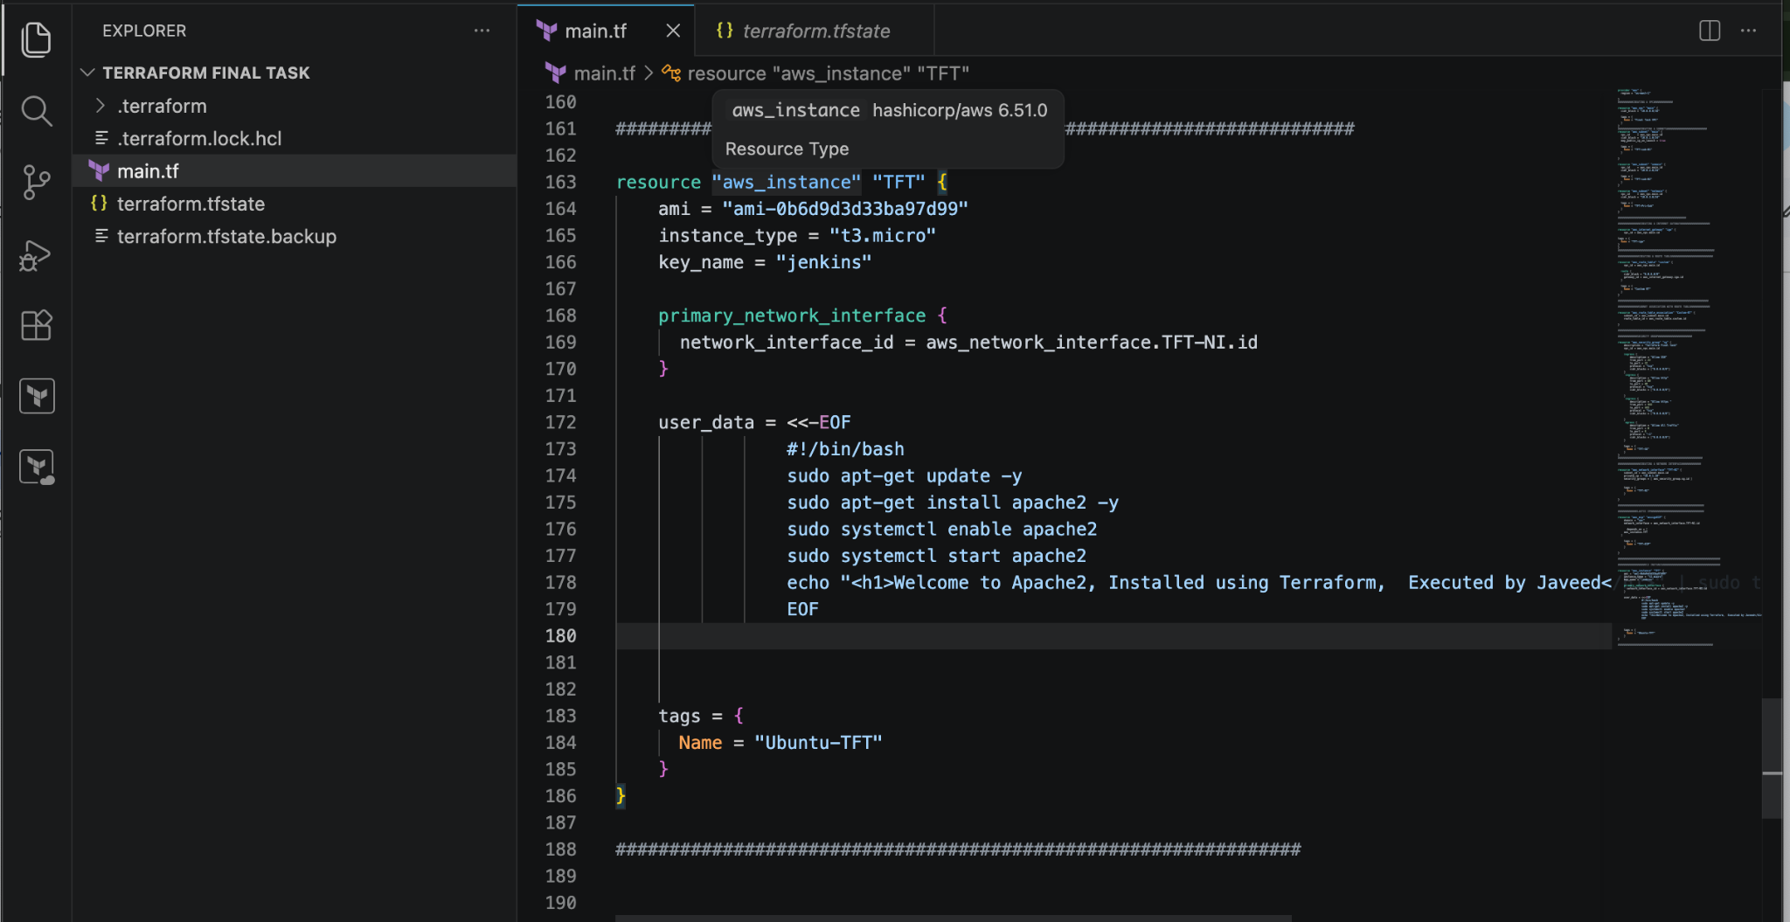
terraform apply
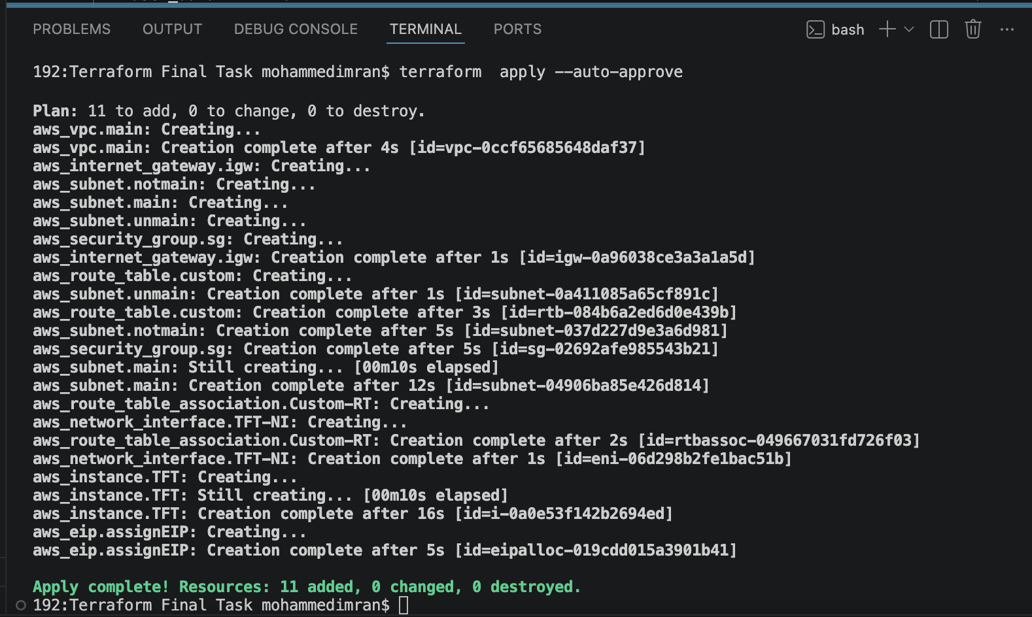
Confirming in AWS
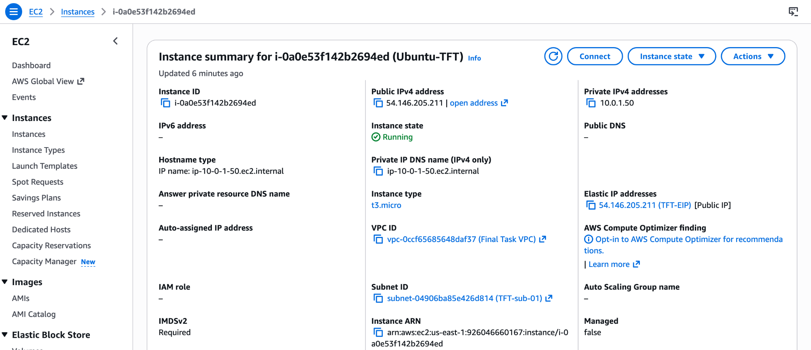
Lets check if our script has been executed
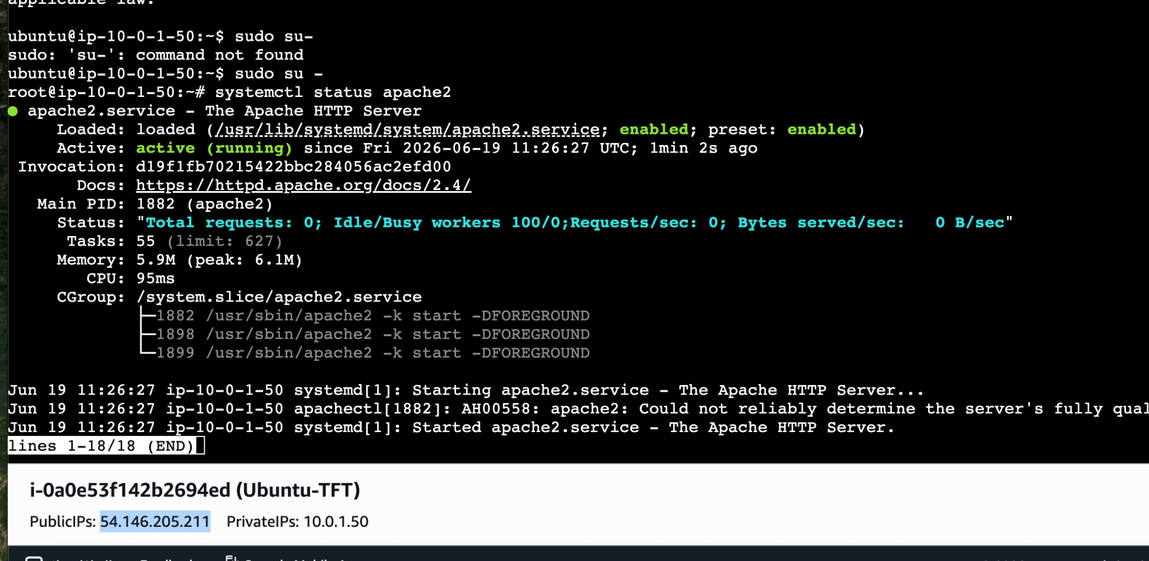
In browser too
